**Built for Digital Education: Dahua launches DeepHub Smart Classroom Solution**

June 27, 2023 / Hangzhou China. Dahua Technology, a world-leading video-centric AIoT solution and service provider, launches the Dahua DeepHub Smart Classroom Solution in an [online launch event](https://youtu.be/5XUpLuQkqdI). Build for digital education, this solution combines Dahua's hardware and software features as well as other products to enhance interactive learning for K-12 and higher education classrooms.

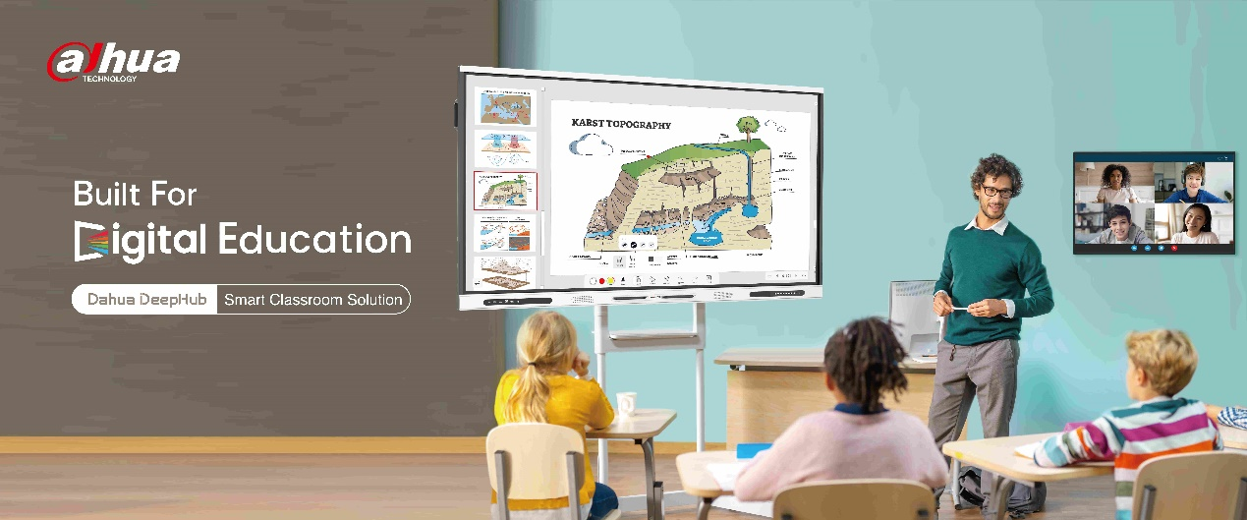

One of the distinguished guests, school teacher and Montessori Australia Ambassador Gavin McCormack, kicked off the event with a keynote speech about the future of digital education. He emphasized, “Skills like communication, collaboration, time management, and proactive learning are extremely important if our students are going to be ready for tomorrow. Innovative tools like the Dahua DeepHub solution not only allows our students to be proactive and innovative within their setting of their classroom, but they also have an opportunity to have outreach within their community and right across the planet. Ultimately, that is our students get to change the world and make it better through the power of education and technology.”

**Combining both hardware and software capabilities**

Following the success of the Dahua DeepHub smart interactive whiteboard launched in 2022, Dahua introduced two new models for education this year: **Lite Series** (DHI-LPH65/75/86-ST420) and **Pro Series** (DHI-LPH65/75/86-ST470-P). Both series are available in sizes ranging from 65 to 86 inches and feature 4K displays. The Lite series is highly competitive and well-received among budget-conscious customers. The Pro series on the other hand offers additional high-end features including 8-core high performance processing CPU, Type-C with 65W PD charging, optional plug-in camera and built-in 8 array mic, among others.

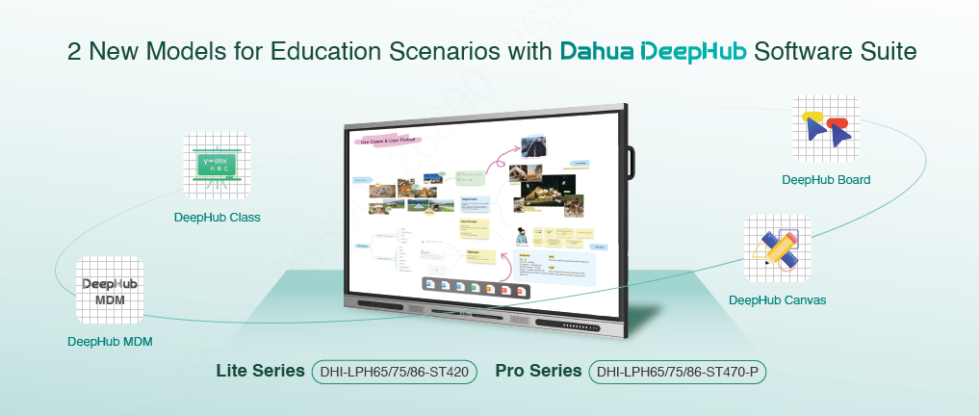

Moreover, another significant highlight of the event is a set of easy-to-use software that promotes more effective teaching methods while enabling an interactive and engaging learning experience for students. The suite includes **DeepHub Class**, which offers various subject teaching tools to increase student interaction; **DeepHub Canvas**, which realizes shape and handwriting recognition, as well as online image and video search; **DeepHub Board**, which gathers creative ideas with the help of its sticky notes, voting, images, videos and drawing capabilities; and **DeepHub MDM**, which provides management functions such as device status viewing, remote application installation, remote control, report exporting, etc.

**4 teaching scenarios**

With Dahua DeepHub whiteboard as its core and using software functions to further enhance its value, the Dahua DeepHub Smart Classroom Solution is specifically designed for four typical digital education scenarios: **Lecture**, **Seminar**, **Hybrid**, and **Sharing**.

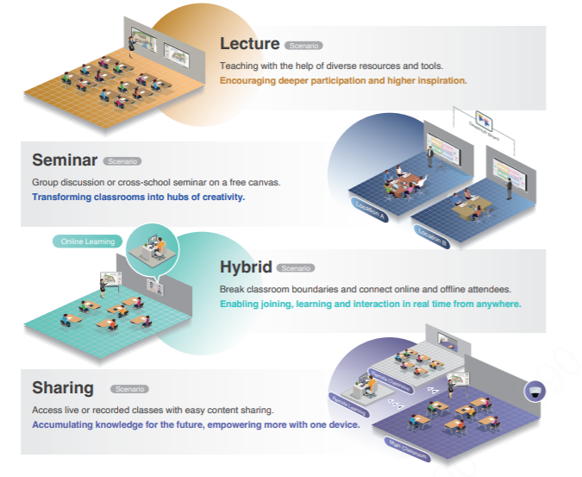

In lecture scenarios, teachers can prepare lessons at home or anywhere with the help of diverse tools, including cloud storage. In addition, it also supports interactive games, customized teaching resources, one-click setup for various subject tools and widgets, 1,000-plus dynamic and engaging learning simulations, convenient files and objects demo via document camera, and more.

For seminar scenarios, this solution enables collaborating across institutions on a free canvas using DeepHub Board. Each team member can contribute their ideas on the canvas, eliminating the limitations on distances and locations for seminars, group discussions, and meetings. It supports over 200 students and over 1,000 viewers at the same time.

In hybrid scenarios, teachers can interact with both online and in-person students, knowing their learning status in real time. Students can easily interact with the content shared by teachers through their own devices or remotely access their online courses, providing a conducive learning environment similar to being physically present in the classroom.

For sharing scenarios, the built-in recording software of Dahua DeepHub supports one-click content sharing that is beneficial for after-class studying. With professional configuration of classroom cameras and recording servers, it supports real-time tracking of teaching activities to provide students with immersive learning experience.

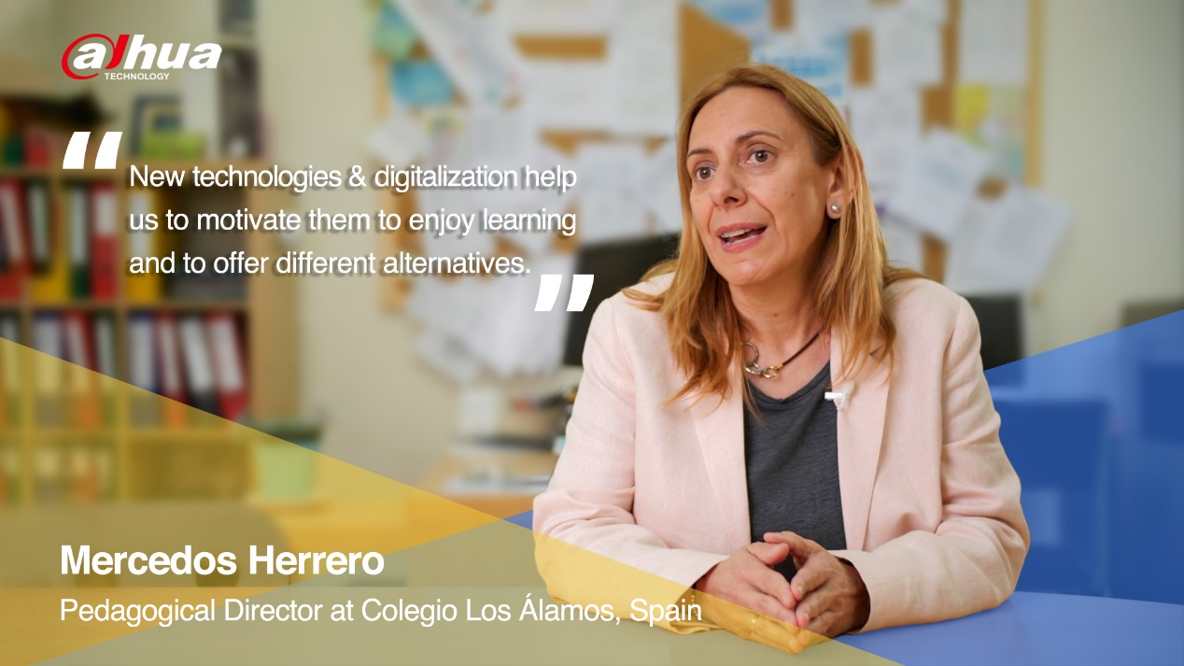

Dahua has been exploring the education vertical market for many years and has provided various competitive smart education solutions to over 150,000 schools. During the online event, representatives from Colegio Los Álamos in Spain and Monfort Youth Center in Malaysia also shared their experiences in collaboration with Dahua and insights on innovative education practices. Notably, Dahua DeepHub has also integrated with well-known third-party platforms to empower modern classrooms with rich curriculum resources through powerful joint solutions.



A deep insight into the learning process is of paramount importance in the education industry. The Dahua DeepHub is making every effort to promote deeper collaboration, deeper participation, and deeper thinking in order to bring new inspirations in modern classrooms. Moving forward, Dahua will continue to utilize its expertise in AIoT, and actively promote the construction of digital education with its ecosystem partners, greatly empowering the future of education with science and technology.

For more details about Dahua DeepHub, please visit[here](https://www.dahuasecurity.com/singlePage/custom/Dahua-DeepHub-Smart-Interactive-Whiteboard).

_______________________________________________________________________________

***About Dahua Technology***

*Dahua Technology is a world-leading video-centric AIoT solution and service provider. Based on technological innovations, it offers end-to-end security solutions, systems, and services to create values for city operations, corporate management, and consumers. With more than 23,000 employees (over 50% R&D technicians), Dahua has deployed its products, solutions, and services in 180+ countries and regions, covering key industries including smart city, traffic management, building, retail, banking & finance, education, energy and more. With in-depth insights and layout of AIoT, Dahua continues to explore emerging fields and has already established businesses in machine vision, robotics, display & control, automotive electronics, memory storage, smart thermal imaging, etc. Since 2014, Dahua Technology has been estimated to be the world’s second largest supplier of video surveillance equipment, and has been ranked 2nd on the a&s Security 50 list for 5 consecutive years.*

*To learn more, visit the* [*Dahua*](https://www.dahuasecurity.com/newsEvents/blog) *Blog or follow us on*[*Facebook*](https://business.facebook.com/DahuaHQ/)*,*[*LinkedIn*](https://www.linkedin.com/company/dahua-technology/)*,*[*YouTube*](https://www.youtube.com/user/DahuaTechnology)*and*[*Twitter*](https://twitter.com/DahuaHQ)*.*

***Media Contact***

[PR_Global@dahuatech.com](mailto:PR_Global@dahuatech.com)